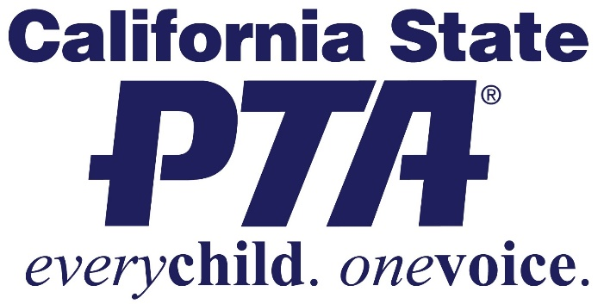
BE HEARD AND MAKE A DIFFERENCE!
BECOME A PTSA OFFICER
The Milpitas High School PTSA
is seeking for candidates for the 2018-2019 School Year!
Open positions include:
- President – presides at all meetings of the association and executive board.
- Vice President – serves as the primary aide to the president. Perform the duties of the president in the absence or disability of that officer to act.
- Secretary – keep an accurate record of the proceedings of all meetings of the association. Be prepared to refer to minutes of previous meetings.
- Treasurer – chair the budget committee and prepare the budget for adoption by the association. Keep such permanent books of account and records as shall be sufficient to establish the items of gross income, receipts and disbursements of the association.
- Historian – assemble and preserve a record of the activities, achievements and volunteer hours of the association. Assist the president with the preparation of the association’s annual report required by the CA State PTA.
Contact mhsptsanominatingcom@gmail.com for more information and to get your name on the ballot!
Submissions are due by February 28, 2018.

